Greenpower Data

Total Charge used (sum of raw current \* time interval/1000) = 171 216, which makes it … A.hr

According to the datasheet, (raw current in bins)/(1023bins/range)\*(5V/range)/(0.040 V/A), so total charge = 20920 amp seconds, or 5.8 amp hours

According to low current calibration, /1023\*5/0.0098,for 85391 amp seconds, or 23.7 amp hours.

Driver 1

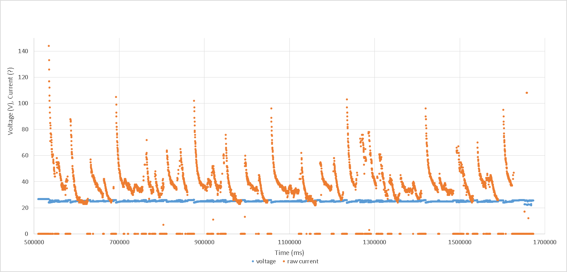

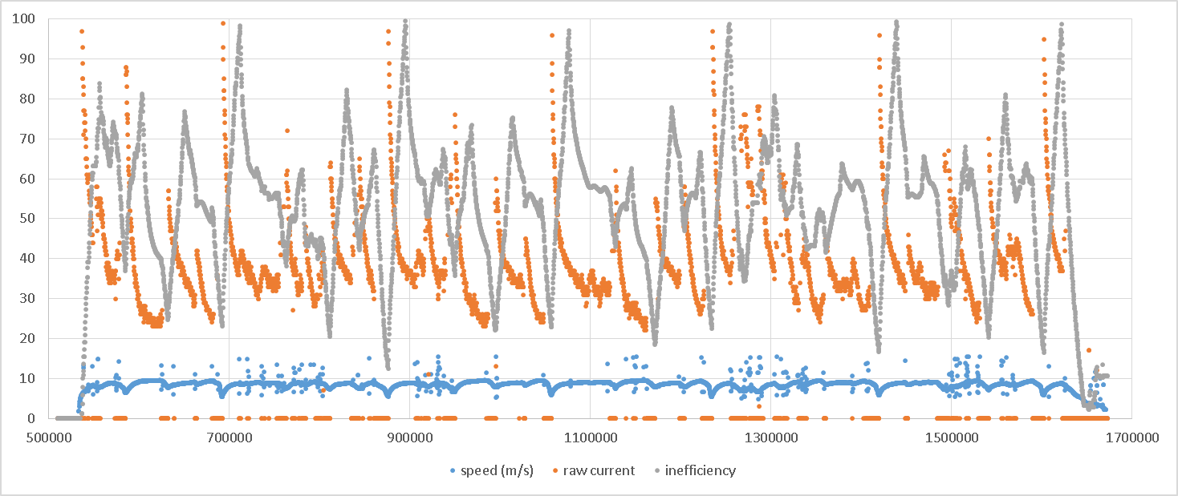

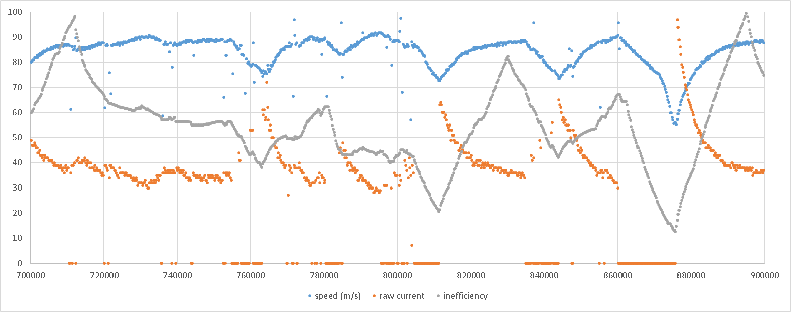

Driver 2

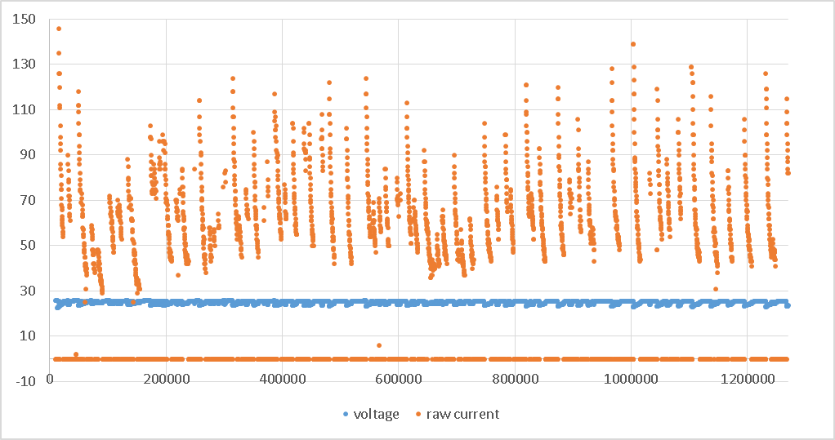

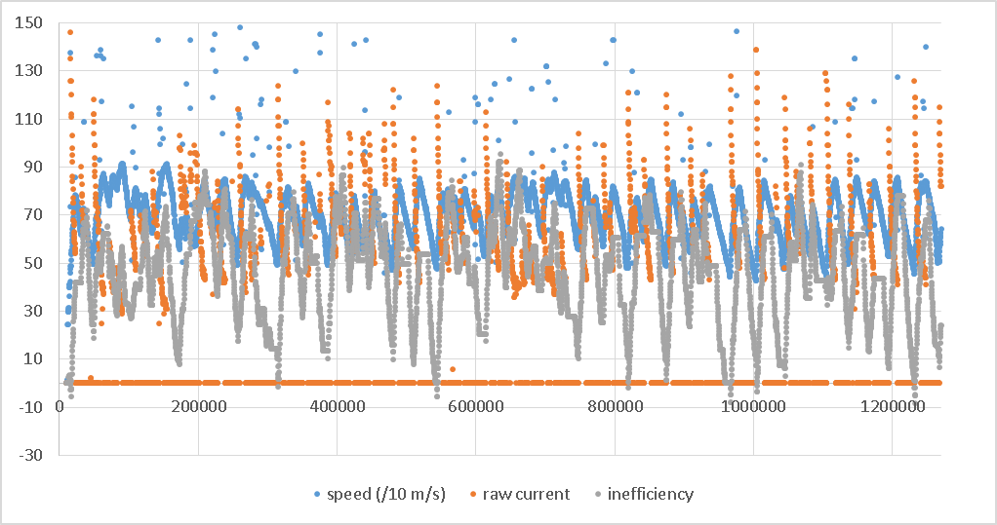

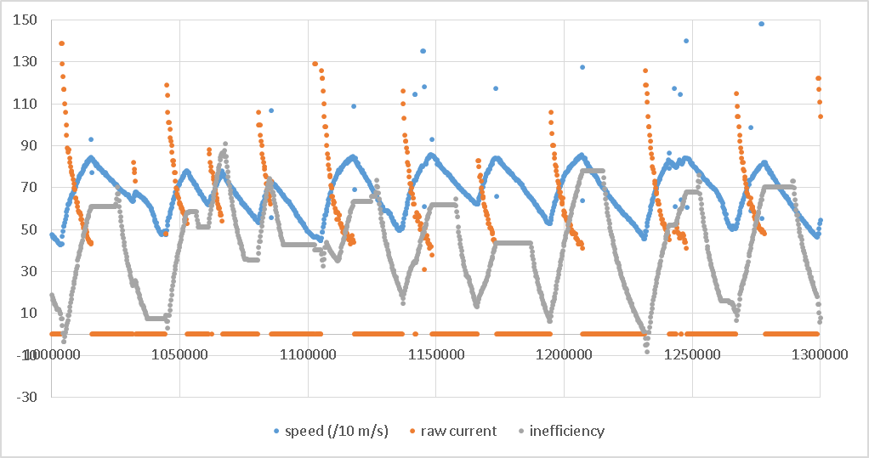

Driver 3

